**Functional Requirement document**



**Online Banking Implementation for 24/7 Account Management**

| Document Version | Version 1.2 |
| --- | --- |
| Prepared By | [Name] |
| Job Title | [Job Title] |
| Date Prepared | [Insert Date] |
| Document Status | Draft / Final |

| **Sr No** | **Version** | **Date** | **Author** | **Changes Made** | **Approval Status** |
| --- | --- | --- | --- | --- | --- |
| 1 | 1 | [Insert Date] | [Name] | Initial Draft | Draft |
| 2 | 1.1 | [Insert Date] | [Name] | Added Business Requirements | Reviewed |
| 3 | 1.2 | [Insert Date] | [Name] | Finalized for Approval | Approved |

Table of contents:

**1. Scope of the document 2**

**2. Business problem statement 2**

**3. Assumptions and dependencies 2**

**4. As-Is-Business 2**

**5. To-Be-Business 2**

**6. Requirements 3**

6.1. Home Page Requirements 3

6.2. Online Banking Page Requirements 3

6.3. New User Registration Page Requirements 5

6.4. Password Page Requirements 8

**7. Issues/Open Questions 10**

# Scope of the document

The goal of the project is to implement ‘Online Banking’ capability. By introducing Online Banking, customers can manage their accounts 24/7, reducing call center dependency and improving service speed. This will not only make banking more convenient but also help the company save on operational costs and call center expenses.

# Business problem statement

Currently, customers rely on call centers and physical branches for basic banking tasks like checking balances, transferring funds, and viewing account statements. This leads to several issues:

1. High Call Center Volume – Many customers call for simple requests, increasing wait times and support costs.
2. Limited Accessibility – Customers can only access banking services during business hours, which is inconvenient.
3. Slow Service – With more people depending on customer support, response times are longer, leading to frustration.
4. Poor Customer Experience – Long hold times and the lack of self-service options make banking less efficient.

# Assumptions and dependencies

NA

# As-Is-Business

[BLANK]

# To-Be-Business

[BLANK]

# 

# Requirements

## Home Page Requirements

* + 1. Display ‘Online Banking’ Hyperlink

The system shall display an **‘Online Banking’** hyperlink on the **Home** page. This link shall be positioned to the **left of the ‘Locations’** hyperlink. Please refer below *Image (i)*

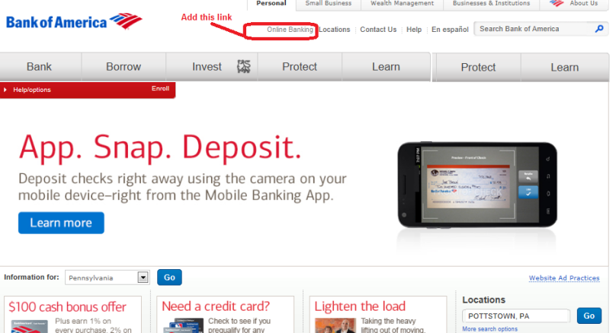

*Image (i)*

* + 1. Display ‘Online Banking’ Hyperlink

When the user clicks on the ‘Online Banking’ hyperlink, the system shall open the ‘Online Banking’ page in the same window.

## Online Banking Page Requirements

* + 1. Data Fields on ‘Online Banking’ Page

The system shall display the following data fields on the ‘Online Banking’ page. Please refer *table (i)* and *Image (ii)*

| **Sr No** | **Field Name** | **Field Type** | **Content** | **Required Field?** | **Min. Char.** | **Max Char.** | **Notes** |
| --- | --- | --- | --- | --- | --- | --- | --- |
| 1 | User ID | Text Box | Alpha-Numeric | No | 8 | 16 |  |
| 2 | Continue | Command Button | N/A | N/A | N/A | N/A | On click, if validation passes, display ‘Password’ page else display error message |
| 3 | New User Registration | Hyperlink | N/A | N/A | N/A | N/A | On click, display ‘New User Registration’ page in the same window. |
| 4 | Forgot User ID? | Hyperlink | N/A | N/A | N/A | N/A | On click, display ‘Forgot User ID’ pop-up/dialogue |

*Table (i)*

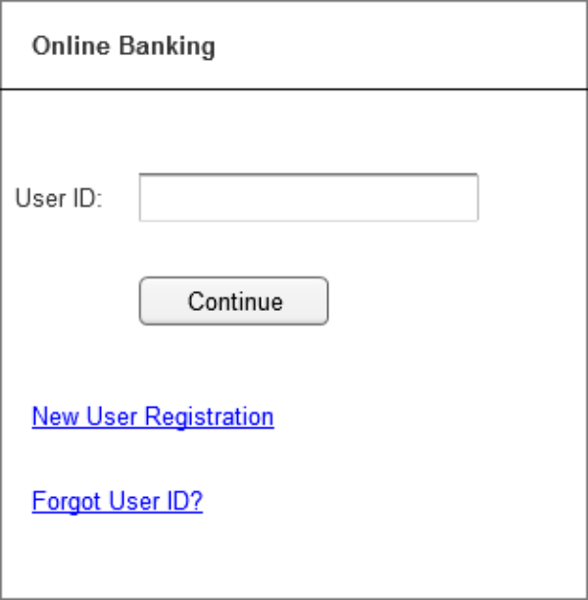

*Image(ii)*

* + 1. User ID Validation

When the user clicks the ‘Continue’ button, the system shall validate the entered User ID.

* + - 1. If the User ID is valid, the system shall display the ‘Password’ page in the same window.
      2. If the User ID is invalid, the system shall display the following error message: "Invalid User ID. Please re-enter a valid value."

## New User Registration Page Requirements

* + 1. Data Fields on ‘New User Registration’ Page

The system shall display the following data fields on the ‘New User Registration’ page. Please check *Table (ii)* and *Image (iii)*

| **Sr No** | **Field Name** | **Field Type** | **Content** | **Required**  **Field?** | **Min.**  **Char.** | **Max**  **Char.** | **Notes** |
| --- | --- | --- | --- | --- | --- | --- | --- |
| 1 | User ID | Text Box | Alpha-Numeric | Yes | 8 | 16 |  |
| 2 | Password | Text Box | Alpha-Numeric | Yes | 8 | 16 | Data is encrypted |
| 3 | Re-enter Password | Text Box | Alpha-Numeric | Yes | 8 | 16 | Data is encrypted |
| 4 | SSN | Text Box | Numeric | Yes | 9 | 9 | Encrypt the first 5 numbers |
| 5 | Gender | Radio Button | Male, Female | No | N/A | N/A | No default selection |
| 6 | Interests | Check Box | Sports, Travel, Movies, Reading | No | N/A | N/A | No default selection |
| 7 | Security Question | Dropdown | What is your best friend’s name?  What is your mother’s maiden name?  What is the make of your first car?  What city were you born?  What is your favorite movie? | Yes | N/A | N/A | Sort the options alphabetically.  No default selection |
| 8 | Security Answer | Text Box | Alpha-Numeric | Yes | 2 | 56 |  |
| 9 | Register | Command Button | N/A | N/A | N/A | N/A | On click, if all validations pass, display ‘Account Summary’ page, else display error messages |
| 10 | Cancel | Command Button | N/A | N/A | N/A | N/A | On click, discard the entered data and display ‘Online Banking’ page. |

*Table(ii)*

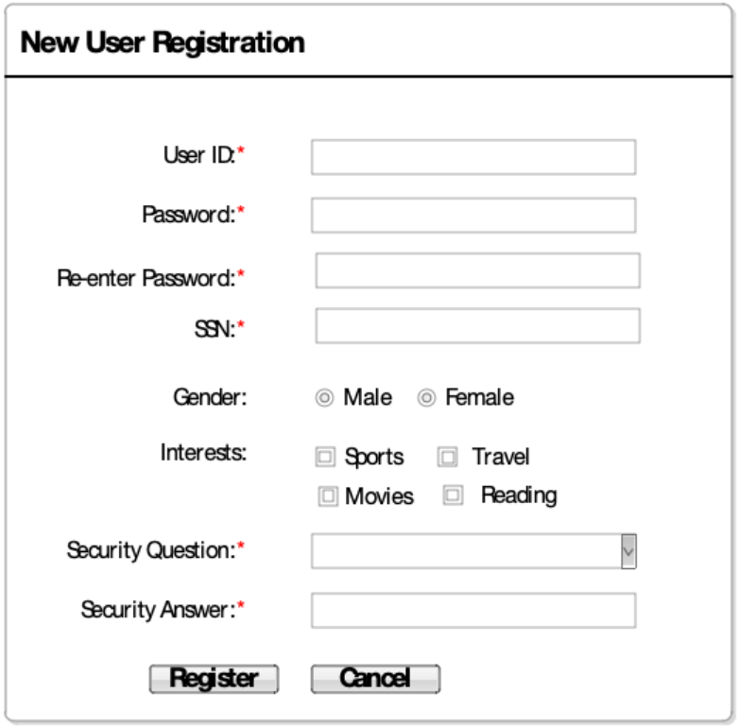

*Image(iii)*

* + 1. Data Validations on ‘New User Registration’ Page

When the user clicks the ‘Register’ button, the system shall perform the following validations:

1. Ensure all **required fields** are entered.
2. Validate that all **entered data** follows the correct format.
3. Verify that the **User ID is unique**.
4. Ensure the **re-entered password matches** the original password.
5. Confirm that the **entered SSN is linked** to an active account.
6. Ensure the **entered SSN is NOT linked** to an existing User ID.
   * + 1. Successful Validation

If all validations pass, the system shall display the ‘Account Summary’ page in the same window.

* + - 1. Failed Validation

If one or more validations fail, the system shall display appropriate error messages indicating the specific issues. Please check error messages list below in the *Table(iii)*

| **Sr No** | **Failed Validation** | **Error Message Displayed** |
| --- | --- | --- |
| 1 | All required data is entered | <Data Field> is a required field. Please enter a value for <Data Field> |
| 2 | All the entered data is valid | Value for <Data Field> is invalid. Please enter a valid value for <Data Field> |
| 3 | User ID is unique | <User ID> is already taken. Please enter a different User ID. |
| 4 | Re-entered password matches with the entered password | The entered password and the re-entered password do not match. Please try again. |
| 5 | Entered SSN is associated with an active account | The entered SSN does not have an active account in the bank. Please re-enter the SSN. |
| 6 | Entered SSN is NOT associated with an active User ID | The entered SSN is already associated with an active User ID. You are not allowed to create multiple User IDs. |

*Table(iii)*

* + 1. Cancel Registration

When the user clicks the ‘Cancel’ button, the system shall discard all entered data and navigate to the ‘Online Banking’ page in the same window.

## Password Page Requirements

* + 1. Data Fields on ‘Password’ Page

The system shall display the following data fields on the ‘Password’ page. Please check the *Table(iv)* and *Image (iii)*

| **Sr No** | **Field Name** | **Field Type** | **Content** | **Required**  **Field?** | **Min.**  **Char.** | **Max**  **Char.** | **Notes** |
| --- | --- | --- | --- | --- | --- | --- | --- |
| 1 | Password | Text Box | Alpha-Numeric | No | 8 | 16 | Data is encrypted |
| 2 | Login | Command Button | N/A | N/A | N/A | N/A | On click, if validation passes, display ‘Account Summary’ page else display error message |
| 3 | Forgot Password? | Hyperlink | N/A | N/A | N/A | N/A | On click, display ‘Forgot Password’ pop-up/dialogue |

*Table(iv)*

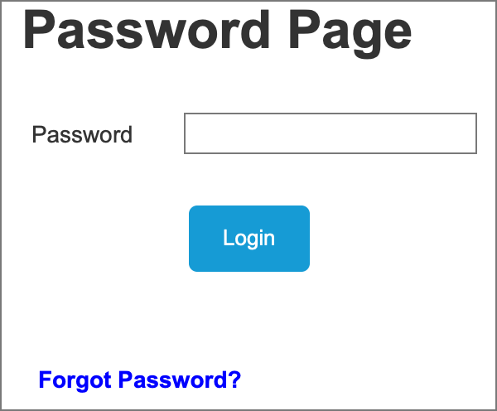

*Image(iii)*

* + 1. Password Validation

When the user clicks the ‘Login’ button, the system shall validate the entered Password.

* + - 1. If the Password is valid, the system shall display the ‘Account Summary’ page in the same window.
      2. If the Password is invalid, the system shall track the password failure count and respond as follows:
         1. If the failure count is less than 3, the system shall display the following error message:

"Invalid password. Please re-enter a valid password."

* + - * 1. If the failure count reaches 3, the system shall lock the account and display the following error message:

"Your account is locked. Please call 1-800-XXX-XXXX to unlock your account."

# Issues/Open Questions

[BLANK]